# COMPUTER NETWORKS LAB 7

## OBJECTIVE:

Creating a Network Topology for RIP / RIPv1 in Packet Tracer.

## **STEPS TAKEN**:

**STEP 1:**

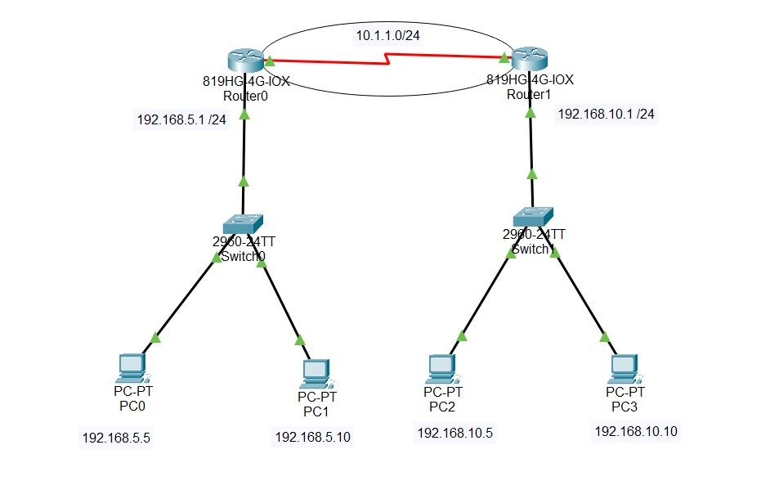

* Link the two routers with a Serial DCE-DTE cable.
* Connect the GigabitEthernet ports of R1 and R2 Routers to the Switch (SW1/SW2) ports with a straight-through cable.
* Connect PC1 and PC2 to SW1, PC3, and PC4 to SW2 with a straight cable.

**STEP 2:**

After typing the below commands on the Router, the connection is successful indicated by the green triangles on the cables below.

Click on the R1 Router you made in the setup, and open the settings. After that, go to the CLI tab. Use the commands below to give IP addresses to R1’s GigabitEthernet and Serial ports.

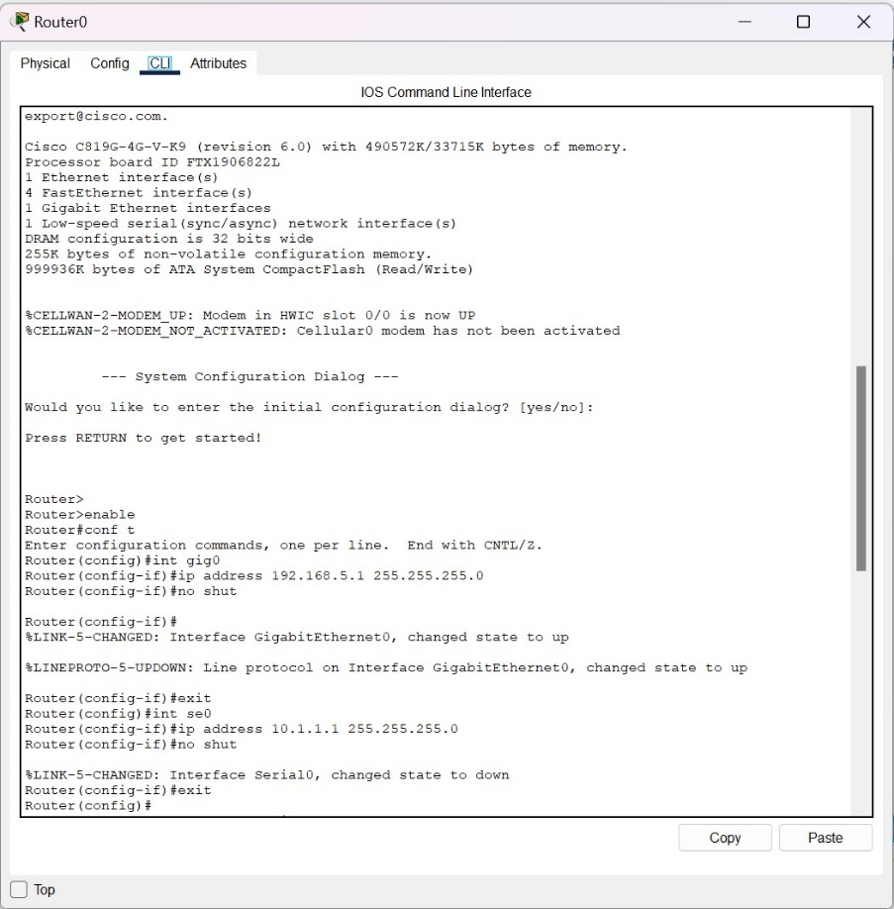

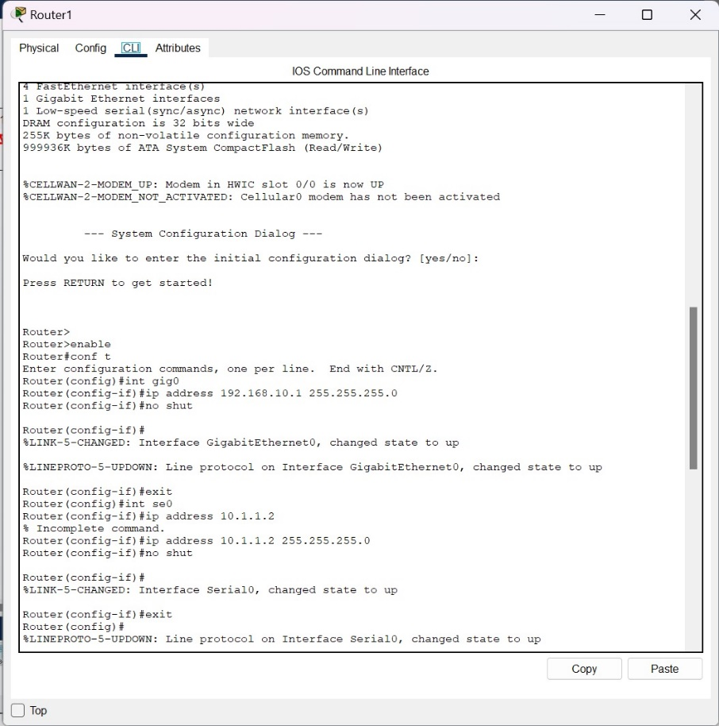

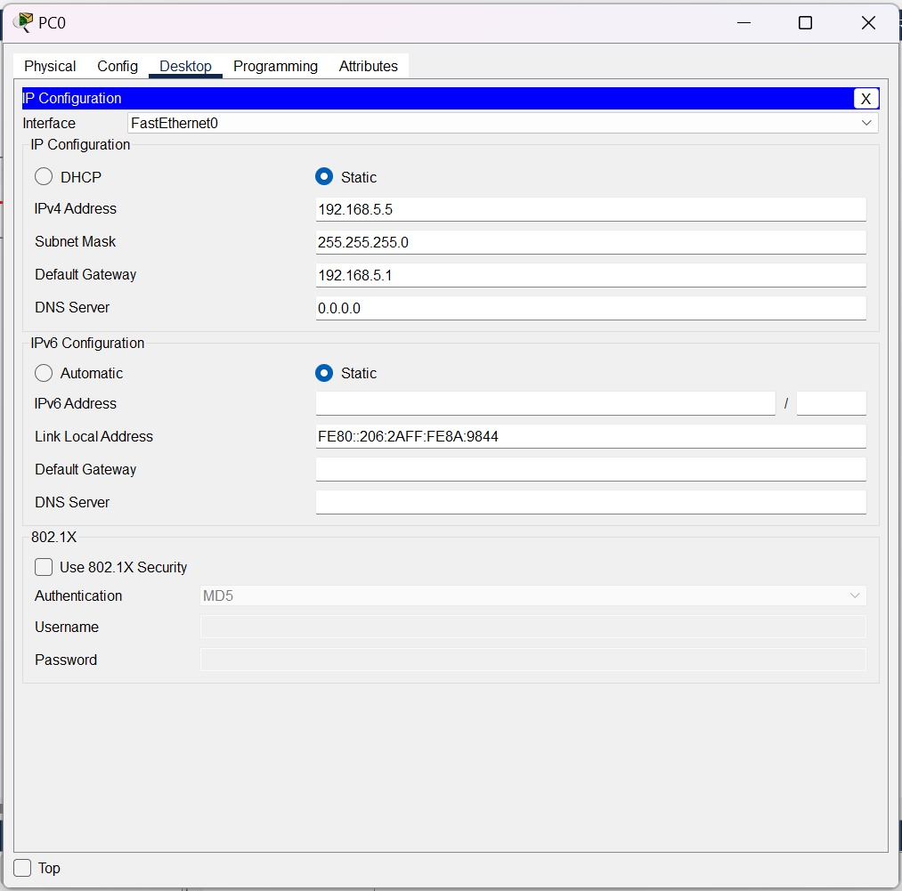

**STEP 3:**

Setting up RIP Protocol

Enabling RIP Configuration

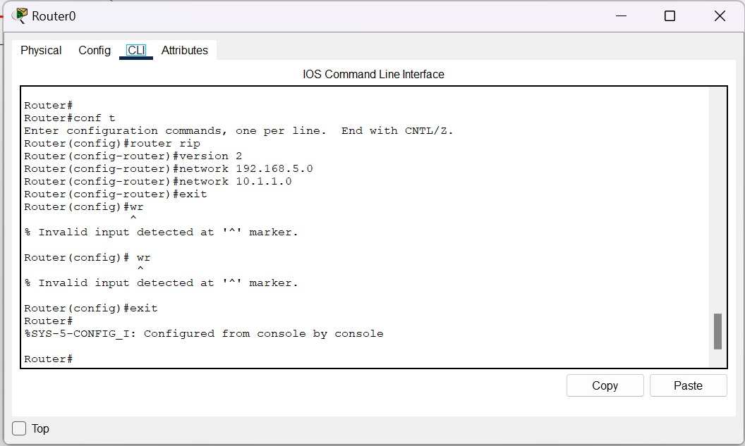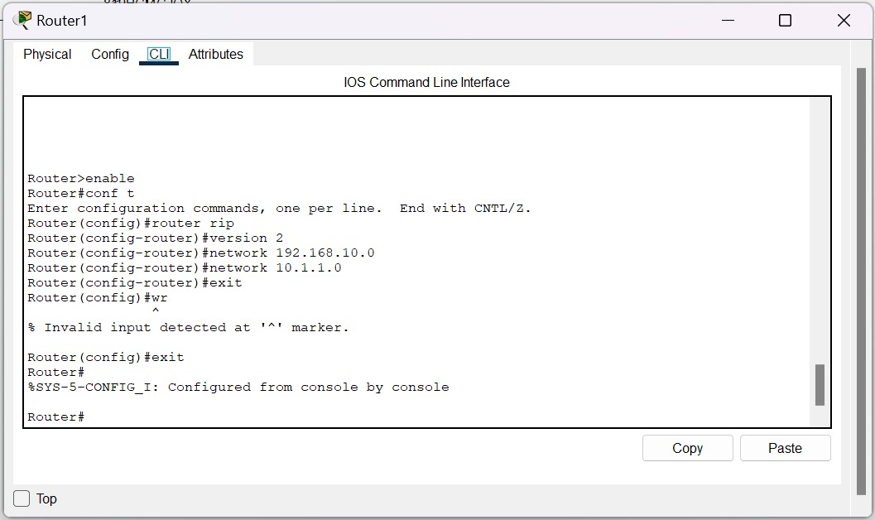

**STEP 4:**

Pinging to check the connectivity

